USER GUIDE FOR IEC TR 61000-4-37 SUPPORT SPREADSHEET

Foreword
This user guide provides instructions how to use the support spreadsheet that is made available as an essential supplement with IEC TR 61000-4-37.
The IEC and the spreadsheet author disclaim liability for any personal injury, property or any other damages of any nature whatsoever, whether special, indirect, consequential or compensatory, directly or indirectly resulting from this software and the document upon which its methods are based, use of, or reliance upon.
The spreadsheet and this user guide are provided free of charge, and free of copyrights.
The spreadsheet is created using Microsoft Office, but can be opened and the calculations can be processed using other spreadsheet programs. The spreadsheet has only been tested under Windows-7 and Windows-8, but should also function correctly in the Android operating system.
Mathieu van den Bergh is assigned within IEC/SC77A/WG-1 as the person to support the spreadsheet and this user guide.
If new versions of the support spreadsheet or this user guide are made available in the future, they can be downloaded from www.cnspoway.com

Mathieu van den Bergh
July 2015
mathieu@cnspoway.com
Functions of the support spreadsheet

Introduction
The IEC TR 61000-4-37 technical report specifies a method to generate known power parameters and current harmonics, using a set of resistive linear and phase controlled loads that are controlled via power electronic circuits. In essence, the current flow through the controlled resistive loads is turned “on” and “off” at user defined phase angles. Through power calculations and Fourier analysis, one can calculate all parameters with very high precision, provided the load values, the current conduction angles, and the applied voltage are known.
The load values may vary slightly, due to component tolerances. Also, the power source used in harmonic emission test systems may have small variations in voltage, or the system may be utilized at nominal 220 Volt instead of nominal 230 Volt. Therefore, the spreadsheet allows for resistive load values, the start/stop phase angles at which the current flow is turned “on” and “off”, and the applied voltage to be specified. These parameters are then used to compute what the “ideal” power parameters for the selected setting should be.
Thus, the user enters the values for linear load, controlled load, system voltage, and the start/stop phase angles in degrees, and the spreadsheet produces the “Calculated parameters” in cells F10 through F19, as well as the current harmonics in cells M2 – M41. In addition, the spreadsheet computes the permitted tolerances for harmonics, per the specified methods in the technical report.
Also, the spreadsheet has individual sheets for each of the test classes in IEC 61000-3-2. In these individual sheets the “ideal” harmonic levels are compared against the limits for the specific test class, and the percentage of limits is indicated, as well as the PASS/FAIL status for each harmonic order.
Thus, the individual test class sheets allow the user to quickly compare the results of a harmonic emission test system measurement with the “ideal” values. The following pages show several examples how to enter and evaluate the values for some of the tests that are specified in IEC TR 61000-4-37.
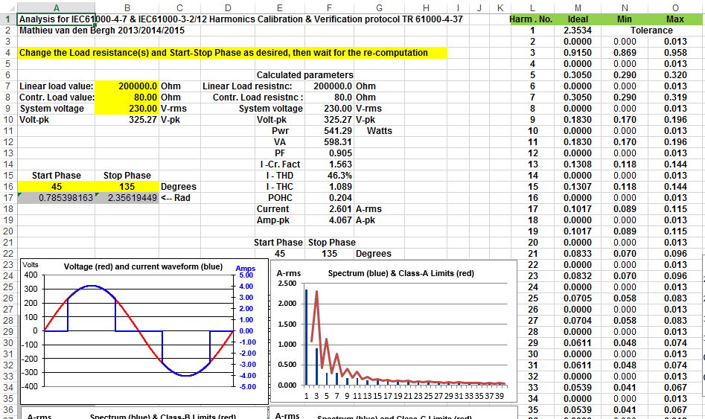
Entering the values for test 1 of IEC TR 61000-4-37
Test no. 1 of IEC TR 61000-4-37 calls for a controlled load value of 80 Ω that is turned “On” at 45 degrees and turned “Off” at 135 degrees. The linear load is not used in this test and therefore its value is set to 100,000 or 200,000 Ω. As follows from figure A-1 in Annex A of the technical report, the linear loads can be turned “on” or “off” individually, with power electronic devices. These devices usually have some very small leakage, which may be 1 – 2 mA. The 100,000 or 200,000 Ω at a system voltage of 230 Volt result in allowing for a leakage current of 1.2 – 2.3 mA. Experience has shown that 1-2 mA is a pragmatic value, and 1 - 2 mA obviously has less than 0.1 % effect on the overall current level, while not affecting the harmonics at all.
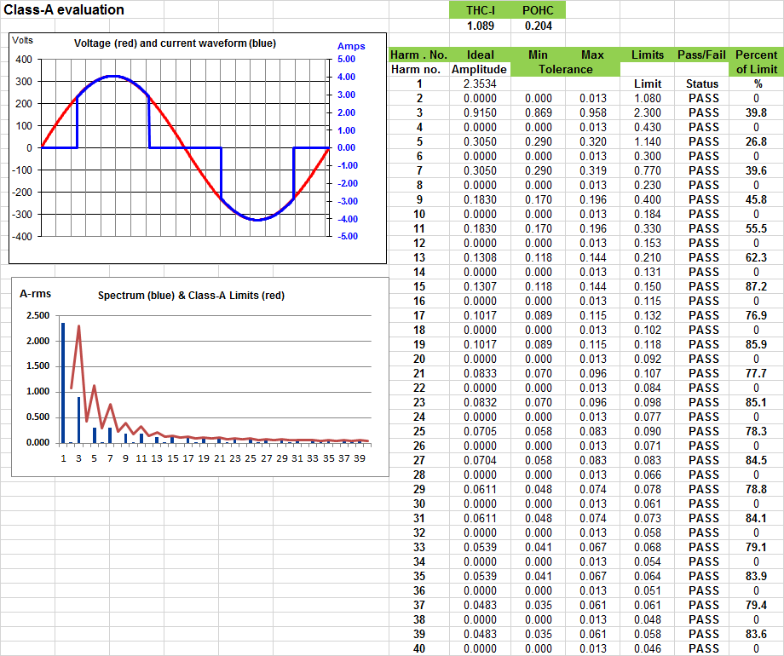
The main sheet called “3-2” allows the user to enter specific values, while the sheet called “Class-A” provides details for the specific test class. Since Test-1 of the technical report is a “Class-A PASS” test, the user can select this “Class-A” sheet to see the harmonic percentages and the PASS/FAIL status. The figure below illustrates the values that are calculated for the specified load levels, and start/stop phase angles. The spreadsheet also computes the THC-I and POHC levels. The calculation below shows the harmonics for settings of exactly 230.0 Volt and 80.0 Ω.
“Class-A Pass” test values per Test no. 1 of IEC TR 61000-4-37
Example for test 1 with minor changes in voltage and load
If the system voltage deviates a little, and perhaps the load is not exactly 80 Ω, the user can make simple adjustments. In cell B8, the actual load value is entered, while the actual voltage is entered in cell B9. The spreadsheet then re-calculates the “ideal” harmonics levels that should result from these settings. The illustration below shows these settings, and the resulting harmonics. Similar to the computation on the previous page, the user can click on the tab for the sheet called “Class-A” to get detailed harmonics data, tolerances, and percentages vs. the Class-A limits.
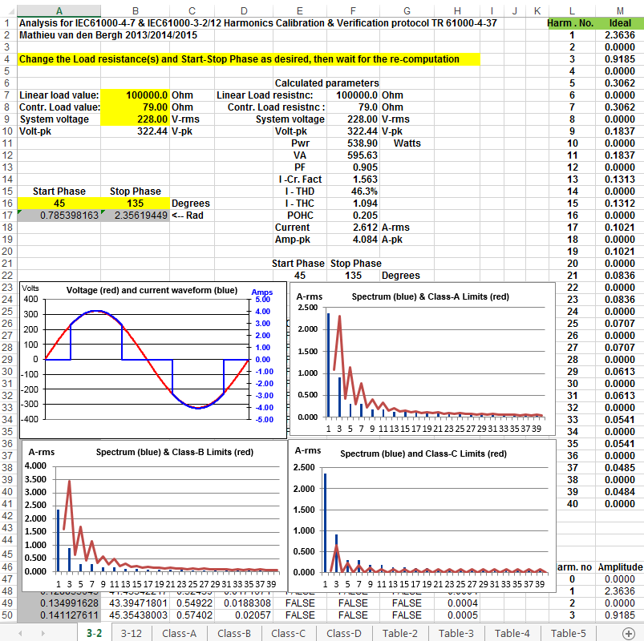
Entering the values for test 2 of IEC TR 61000-4-37
Test no. 2 of IEC TR 61000-4-37 calls for a controlled load value of 61 Ω that is turned “On” at 45 degrees and turned “off” at 135 degrees. The linear load is not used in this test and therefore its value is set to 100,000 Ω.
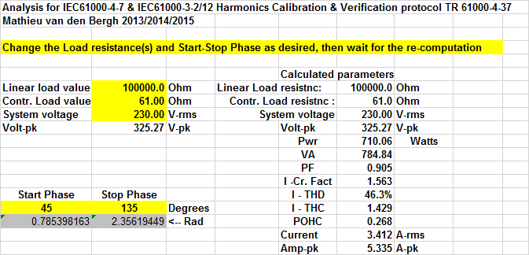
The main sheet called “3-2” allows the user to enter specific values in cells B7, B8 and A16 – B16, as shown to the left.
These settings result in a power level of 710.06 Watt, and the harmonics as shown in the page for sheet “Class-A”.
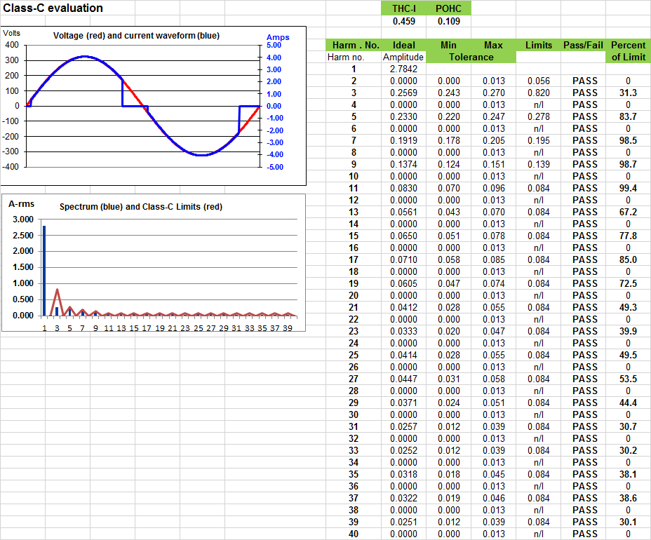
The odd harmonics from H15 – H39 exceed the limits (some by just a small margin), as illustrated below
“Class-A” sheet with computations for test no. 3 of IEC TR 61000-4-37.

Entering the values for test 5 of IEC TR 61000-4-37
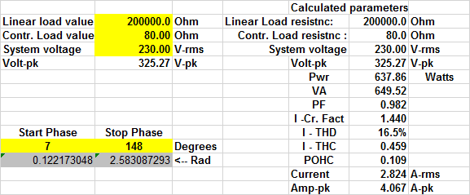
This page shows the settings for a Class-C test with harmonics that just pass the limit. For Class-C, the limits are proportional to current, and thus the load value doesn’t matter too much for this test. The next page shows the computation for a similar Class-C PASS test, but this time with a load of 323 Ω that results in a current of 701 mA instead of the 2.825 Amp for the load of 80 Ω.


Computation sheet for a Class-C test with just harmonics that just pass the limit

Test no. 5 of IEC TR 61000-4-37 for a load level resulting in 0.7 A-rms
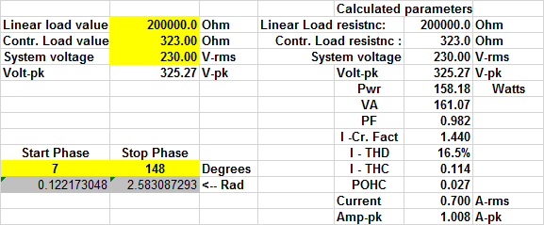
When the load level is changed to 323 Ω the current reduces to 701 mA rms, but the percentages vs. the Class-C limit remain the same as the Class-C limits are proportional to current.
Thus for a lower power test system that cannot support the current for the 80 Ω load, the user may opt for this lower power test.
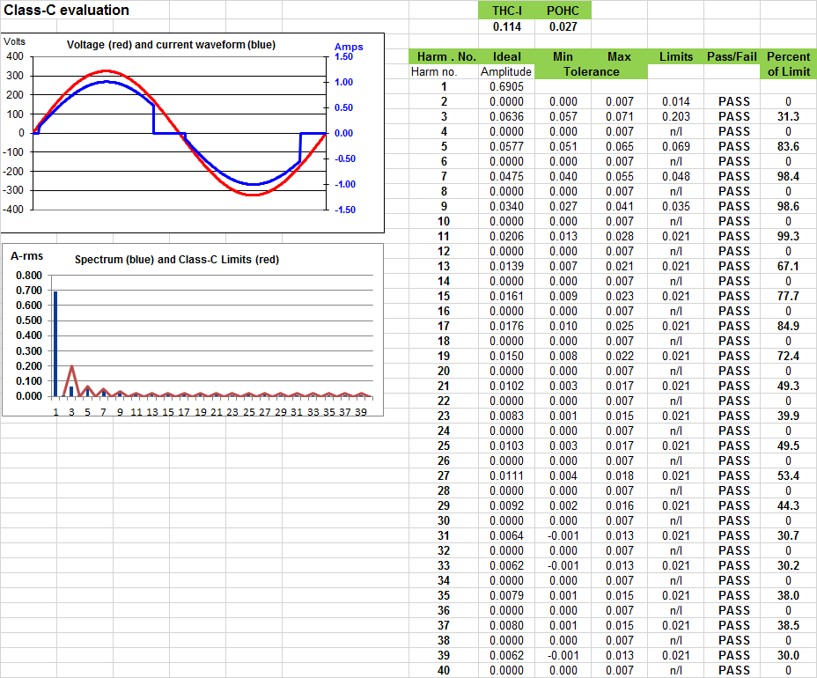
Computations for Test no. 5 with a load level of 323 Ω.

Test no. 10 of IEC TR 61000-4-37 with customized settings - POHC failing the limit
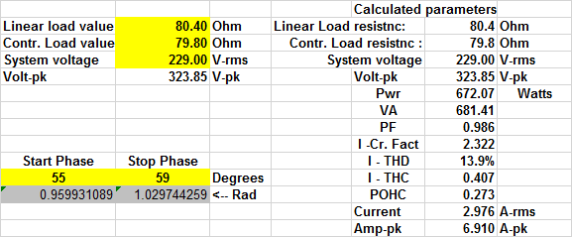
The user can set the values for linear load and controlled load as required, as well as what the actual system voltage is. The POHC level is computed, and varies slightly ( by 1 mA) from the nominal values for test 10 in the technical report.

Computation sheet for test no. 10 with customized load and voltage levels.

Summary
- Cells B7-B8-B9 allow the user to enter the actual load levels and voltages that are used during the test.

- Cells A16 and B16 hold the actual start and stop phase angels, i.e. the angles at which current flow starts and stops.

- Each of the test classes have their own “tab” designated by the Class-A, Class-B, Class-C, and Class-D names.

- The spreadsheet functions with programs such as Open Office, that can import “xlsx” type spreadsheets.

- The user can “play” with the various settings, and generate custom harmonics patterns.

As users gain experience with the spreadsheet, refinements in formatting can be made – for example, to facilitate easy copying of the computations for each test class for comparison with the test report of specific harmonics compliance test systems.

